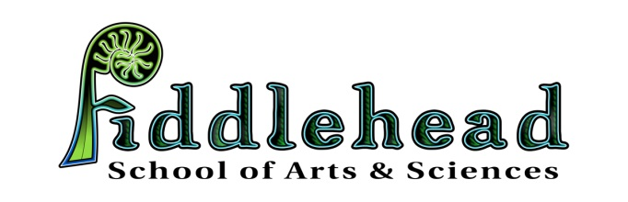

INTENT TO ENROLL FORM FOR SCHOOL YEAR 2019-2020

This confidential Letter of Intent is used to demonstrate interest in having your child attend FSAS, a Pre-K-6 public charter school, for the 2019-2020 school year, to begin on Sept. 3, 2019. This letter does not guarantee your child’s enrollment, nor does it legally bind you to enroll your child in this school. In the event that more students desire enrollment than there are spaces, selection will be made by lottery. For the 2019-20 school year, 6th grade will be a pilot program, open only to our current 2018-19 5th grade class.
PLEASE PRINT CLEARLY
Child's Full Name _______________________________________________________________________
Child’s Grade for the 2019-20 School Year:___________ Date of Birth:_____________
Age by October 15, 2019 _________ PreK applicants: My child will be 4 before Oct. 15, 2019 (yes or no)_______
Name of Current School ___________________________Town of Residence ________________________
Parent/Guardian Name(s)_________________________________________________________________
Home Phone ________________________________________ Cell Phone _________________________
Email Address _________________________________________________________________________
Child’s Home Address____________________________________________________________________
Child’s Mailing Address (if different) ________________________________________________________
Does this child have a sibling that will also be in the lottery? ________
Sibling Name:____________________________Grade_________
Parent/Guardian Signature Date
_________________________________________ ______________________________
Please mail, email or hand deliver this form no later than February 15, 2019 to:
Fiddlehead School of Arts & Science
25 Shaker Rd.
Gray, Maine 04039
Thank you for your interest in Fiddlehead School of Arts & Sciences. Please fill out this form completely. If you have any questions, please contact our office at: (207) 657-2244 or email us at info@fiddleheadschool.org

